Online Exam Management System

User Manual

# **Table of Contents**

**Table of Contents 1**

**Running the Program after Setup 2**

A.I. Exam Generation 5

Exam Generation 7

Manual Exam Generation 8

Automatic Exam Generation 10

Taking an Exam 10

Exam Submissions/Scores 13

Dynamically Managing Questions & Exams 14

Logging in as a Student 17

Logging in as an Instructor 18

Personal Account Management 19

Loading a Class Roster 21

Editing a Student 24

Editing an Instructor 25

## 

## 

## 

## 

## **Running the Program after Setup**

After getting all the program files open in Eclipse you’ll want to run the program.

1. You’ll need to right click on the top of the files tree, hover over **Run As**, then click Spring Boot Apps

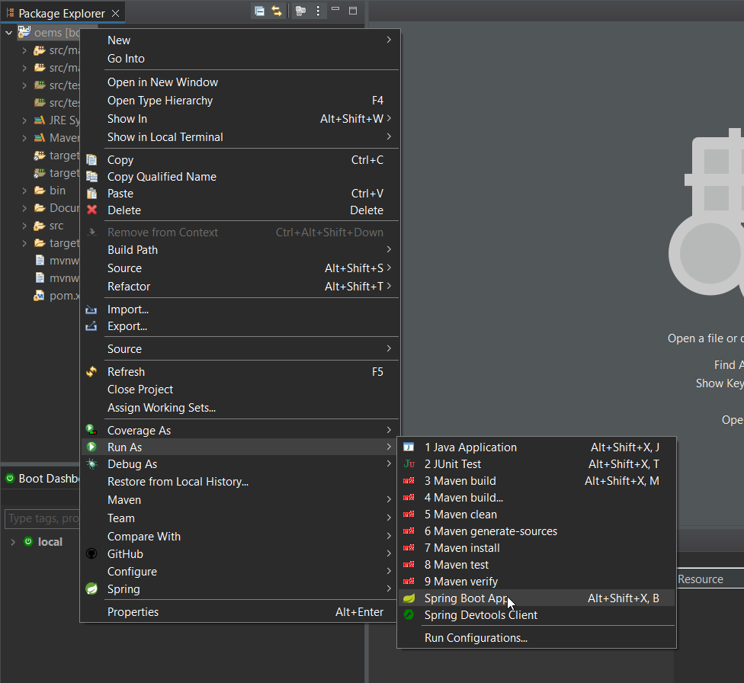

1. You will then need to navigate to your browser of choice and type *localhost:8080* into the url bar. The login page will be displayed.

*user: root, pass: software*

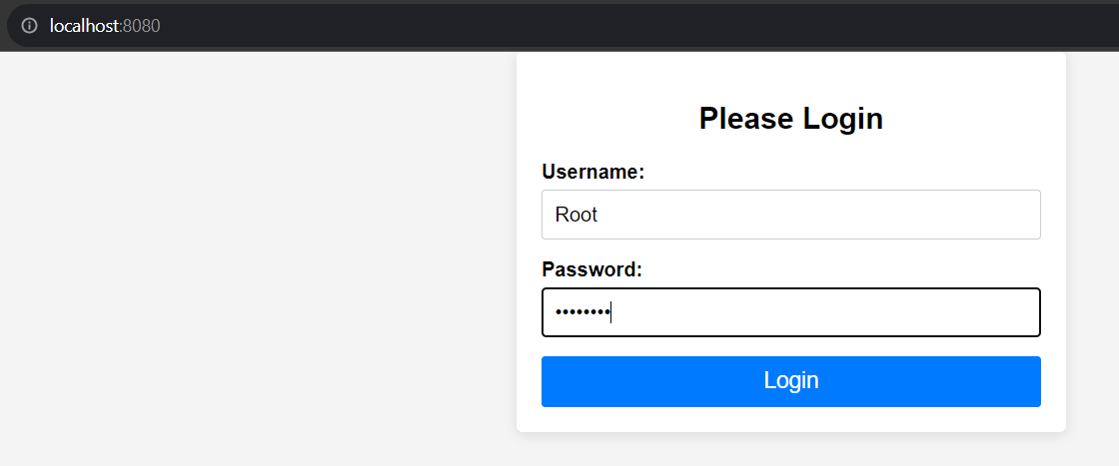

1. After Logging in you will be presented with the Main Screen for an Administrator.

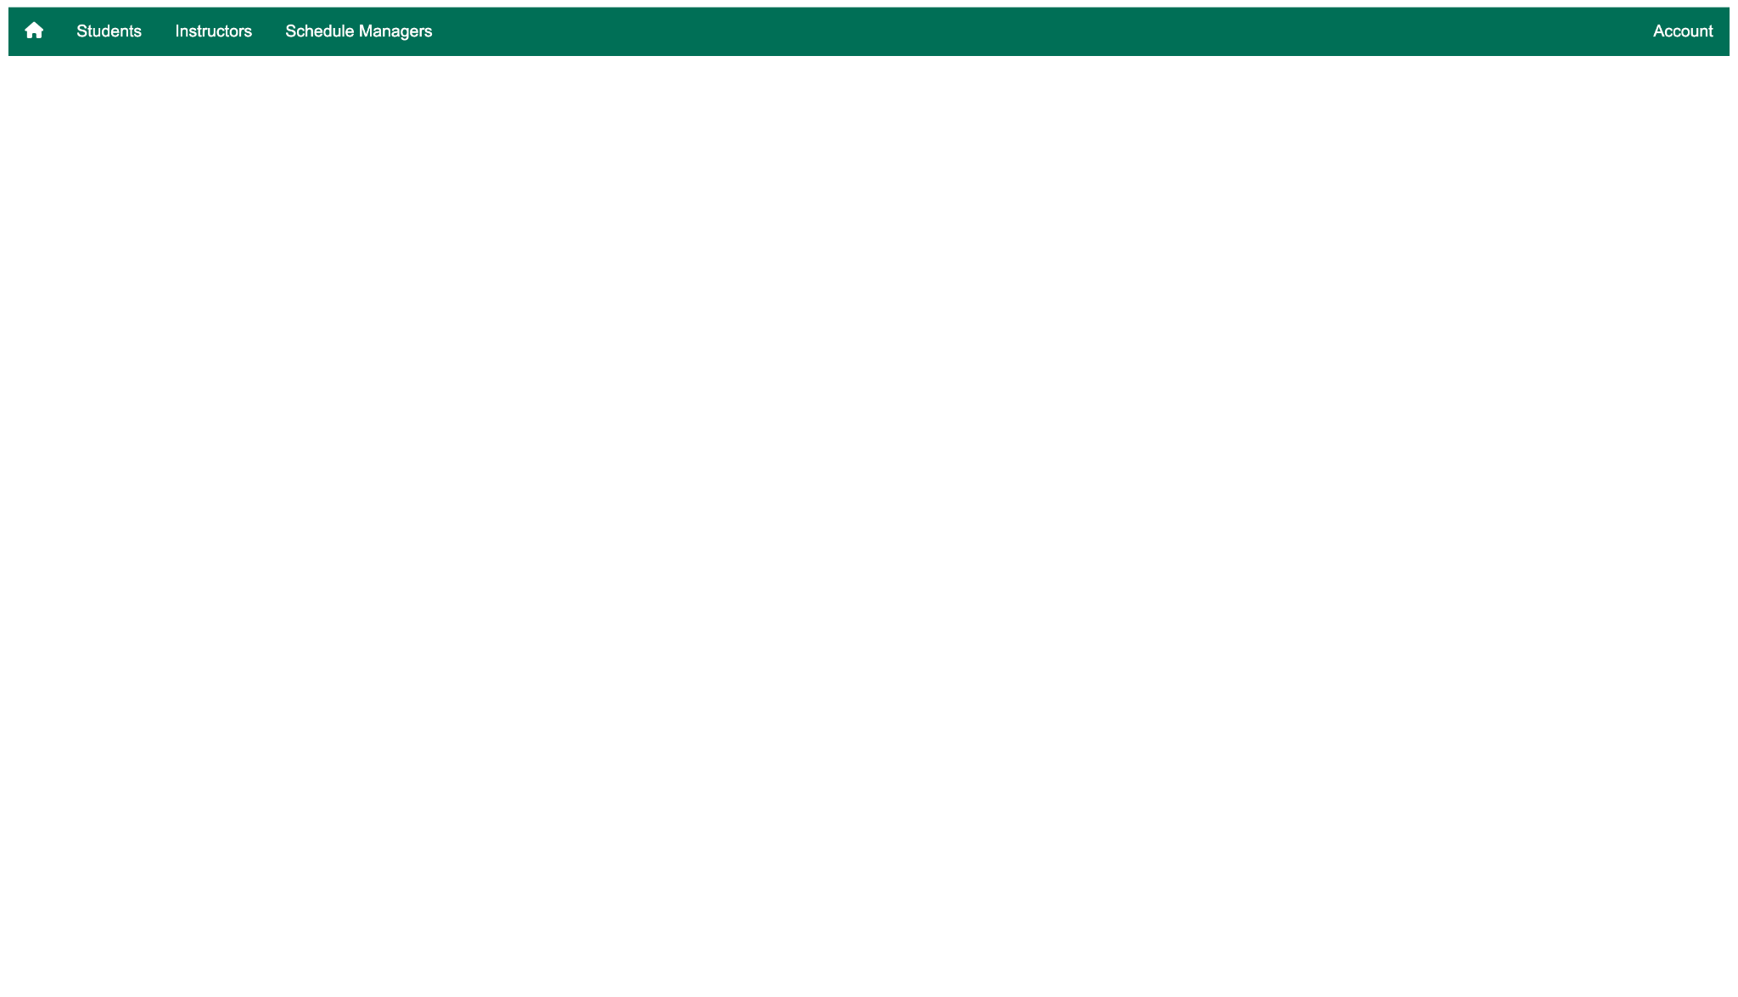

* This is the view of an administrator, the sole role of the administrator is interaction of the database, creating students, instructors and other administrators. They should not have the privilege of interacting with classes or associations.
  + Students
    - The administrator is able to see a list of all students, and is able to edit/delete them directly from the table as shown below:
      * EDIT: Administrator option to edit information of a student
      * DELETE: Administrator option to edit information of a student

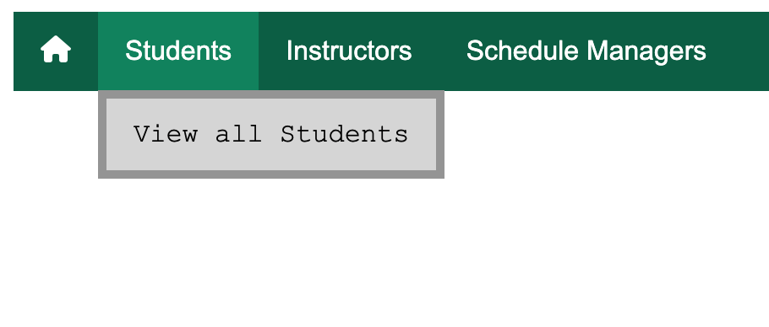

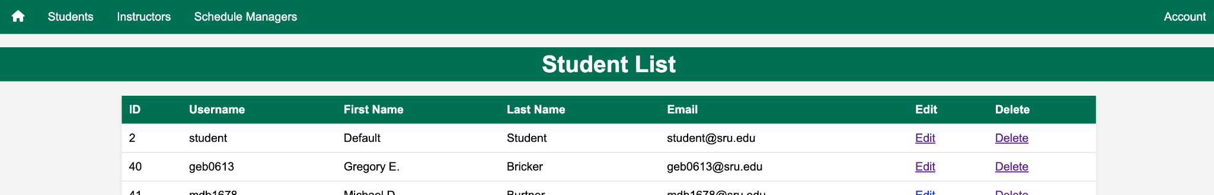

* + Instructors
    - The administrator is able to see a list of all instructors, and is able to edit/delete them directly from the table as shown below:
      * EDIT: Administrator option to edit information of an instructor
      * DELETE: Administrator option to edit information of an instructor

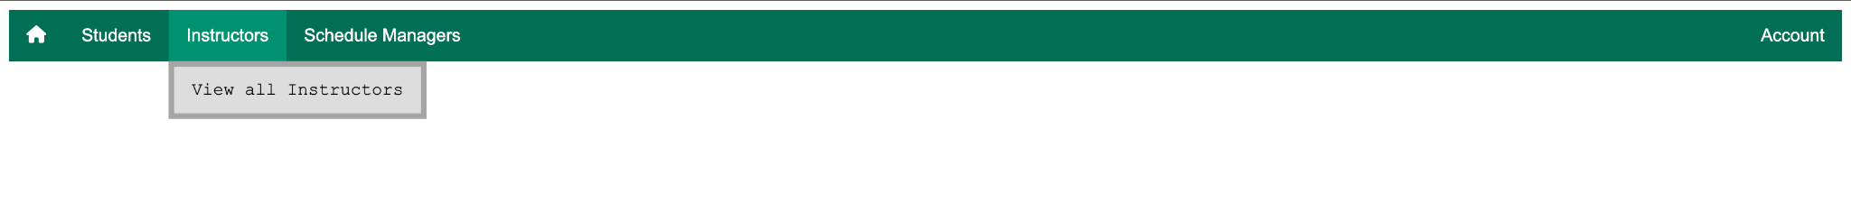

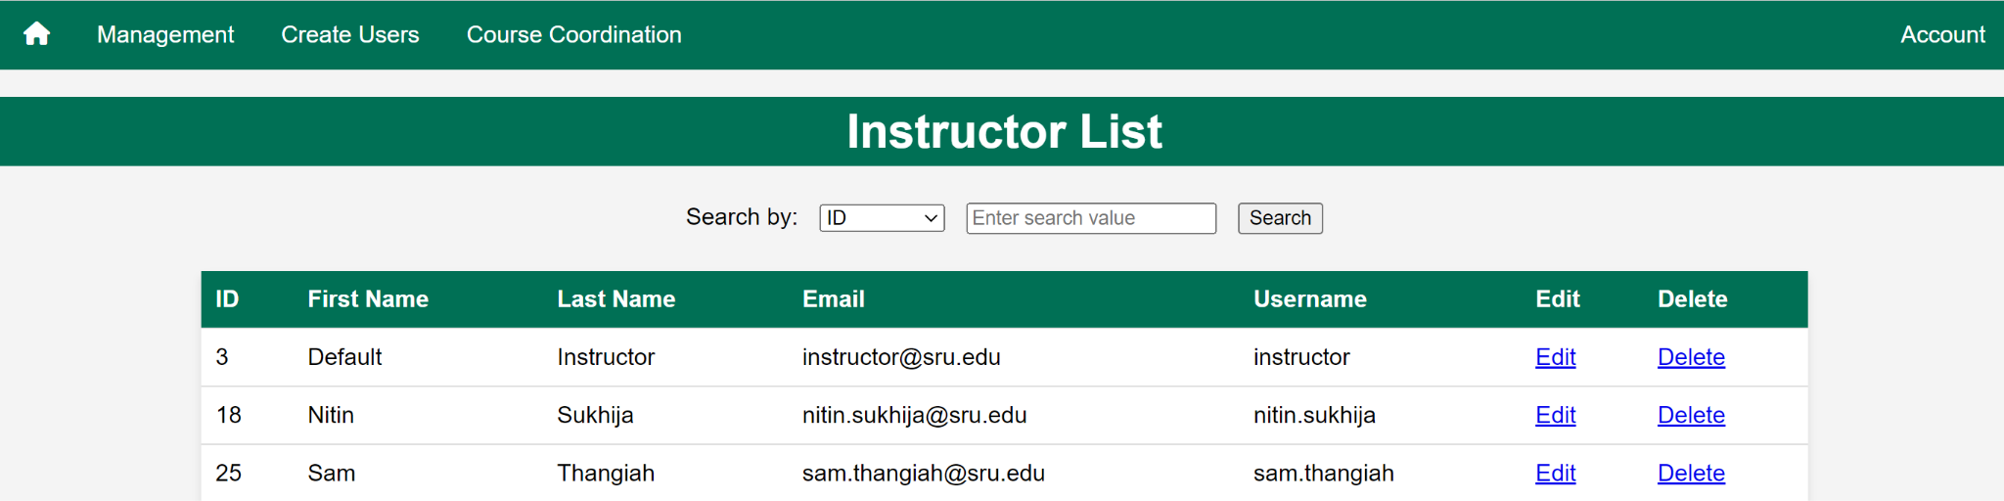

* + Schedule Managers
    - The administrator is able to see a list of all schedule managers, and is able to edit/delete them directly from the table as shown below:
      * EDIT: Administrator option to edit information of a schedule manager
      * DELETE: Administrator option to edit information of a schedule manager

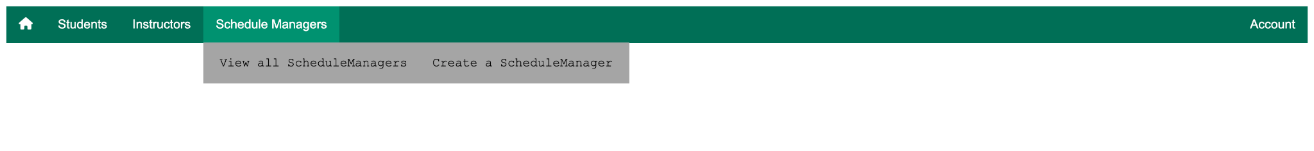

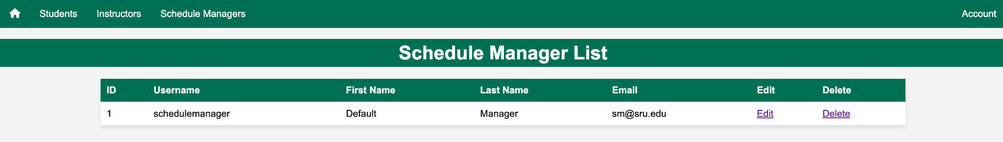

* + - The administrator has an option of creating a schedule manager, the role of a schedule manager is to handle the associations between students and courses, and the creation of students and instructors.

## 

## 

## **A.I. Exam Generation**

1. At the navbar page, hover over **Exam Generation** and click on AI Generate Exam

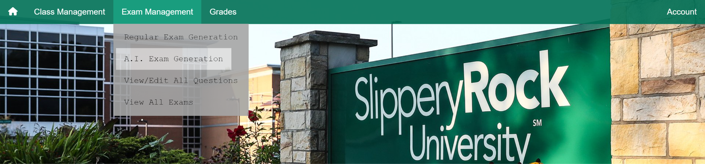

1. You will be met with the following prompt page

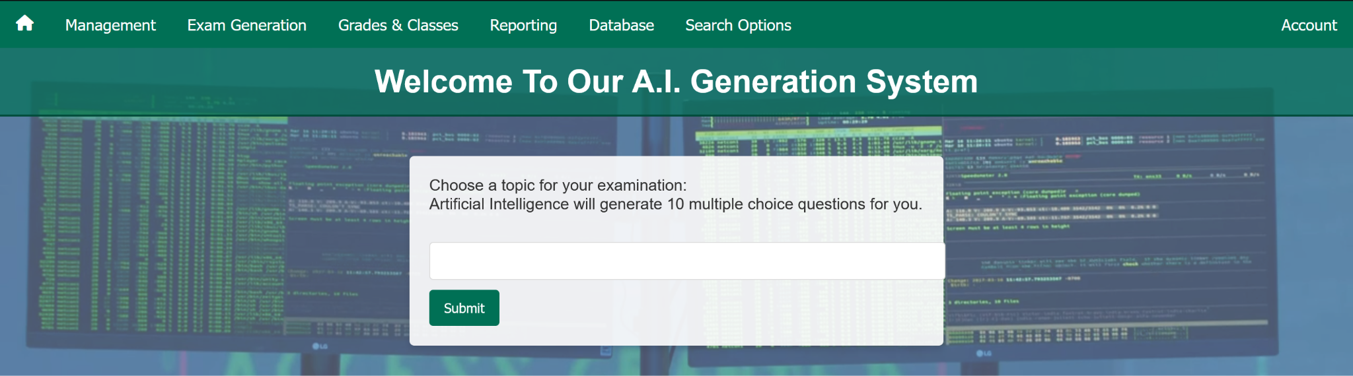

1. Within the prompt box, make sure to write an examination topic of your choice. It can be anything. Click **Submit**
2. You will be met with a confirmation page, click **Yes, proceed** and allow for about 5-10 seconds for the exam to generate itself. There is going to be a progress bar to help you.

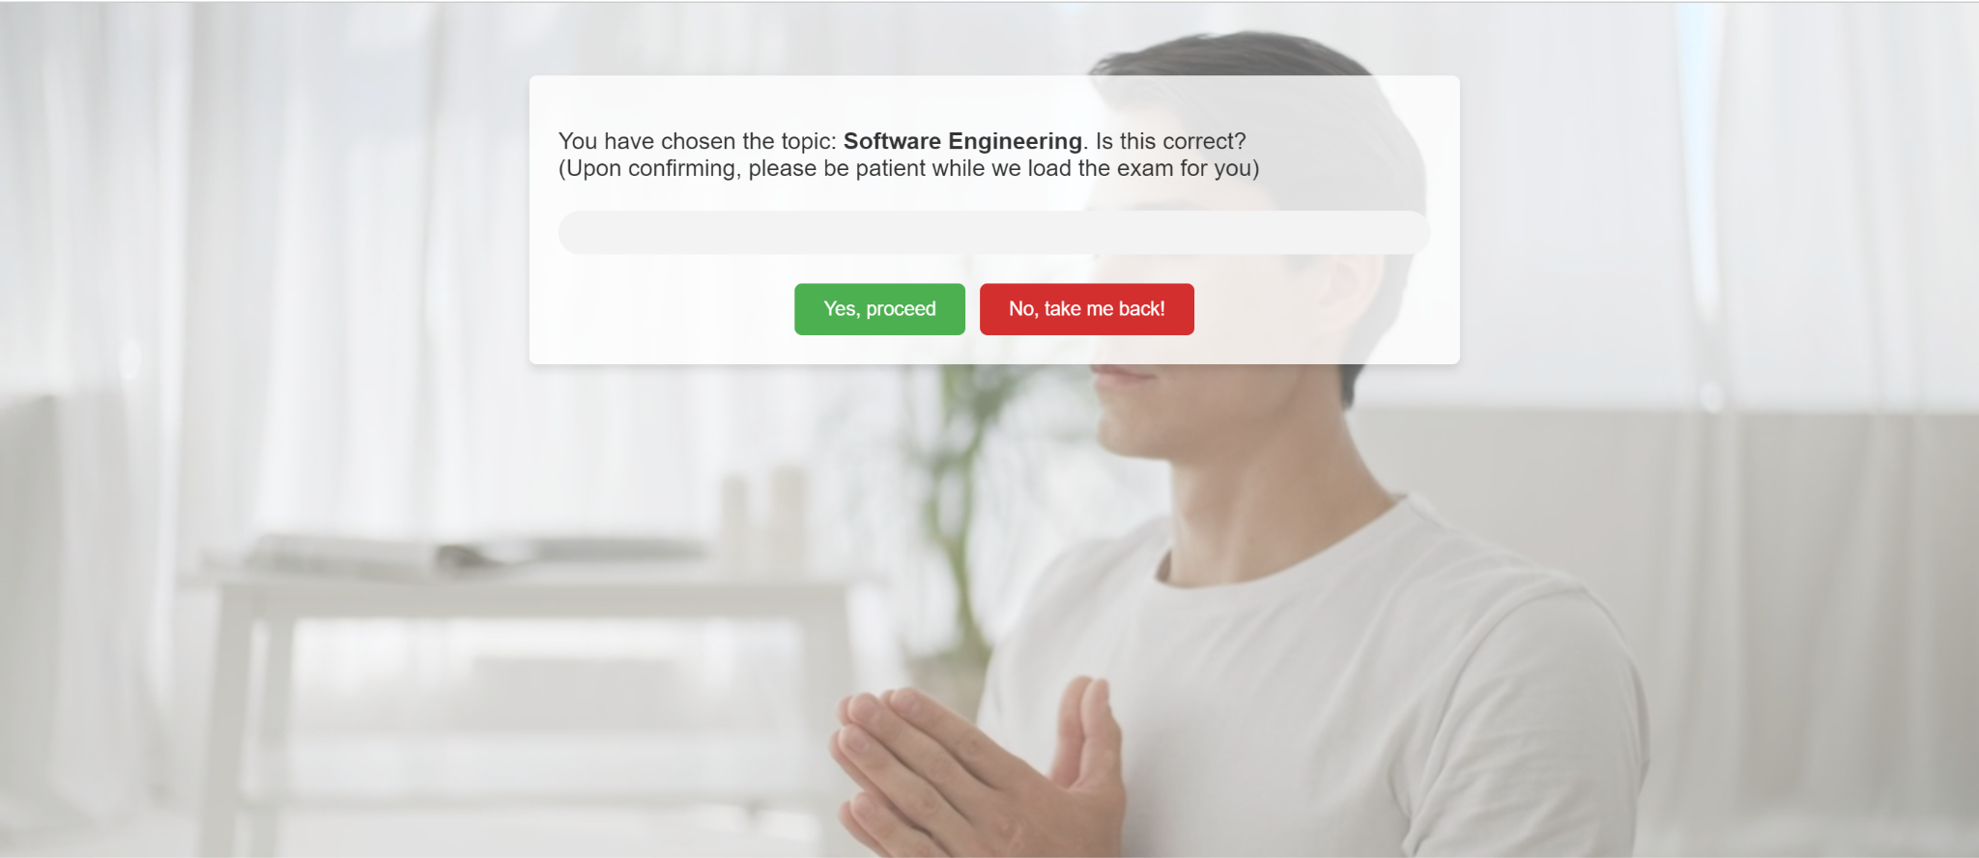

1. Then you will be met with the A.I. generated exam

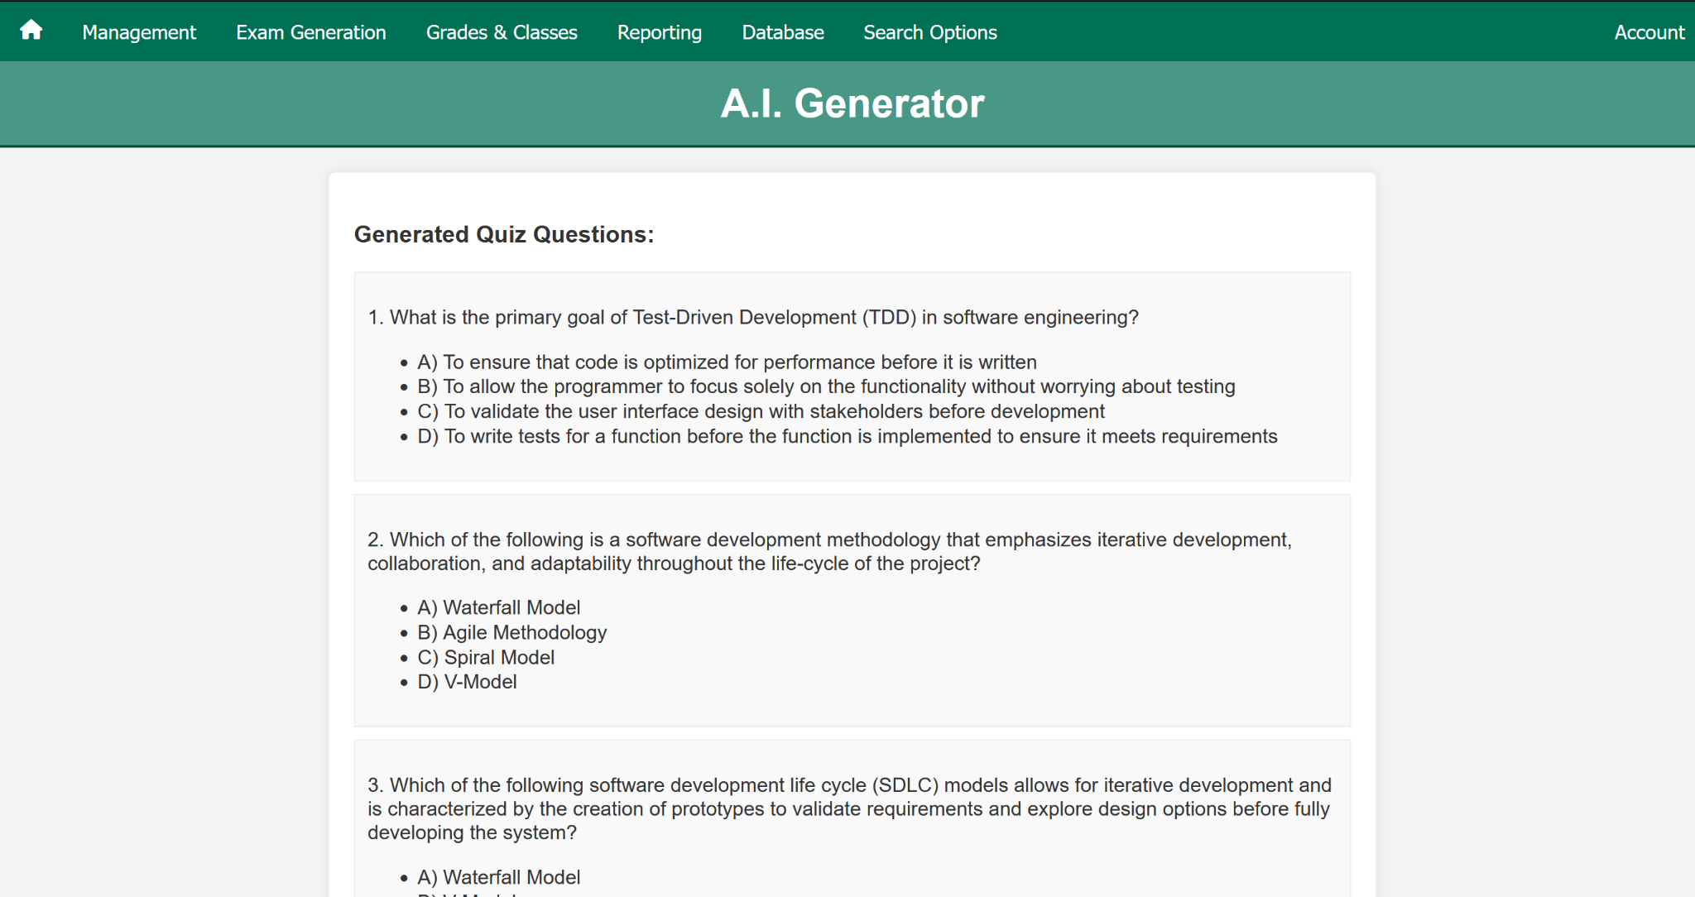

1. You will have an option to export the exam to an excel file or .txt at the **bottom of the page** as such:

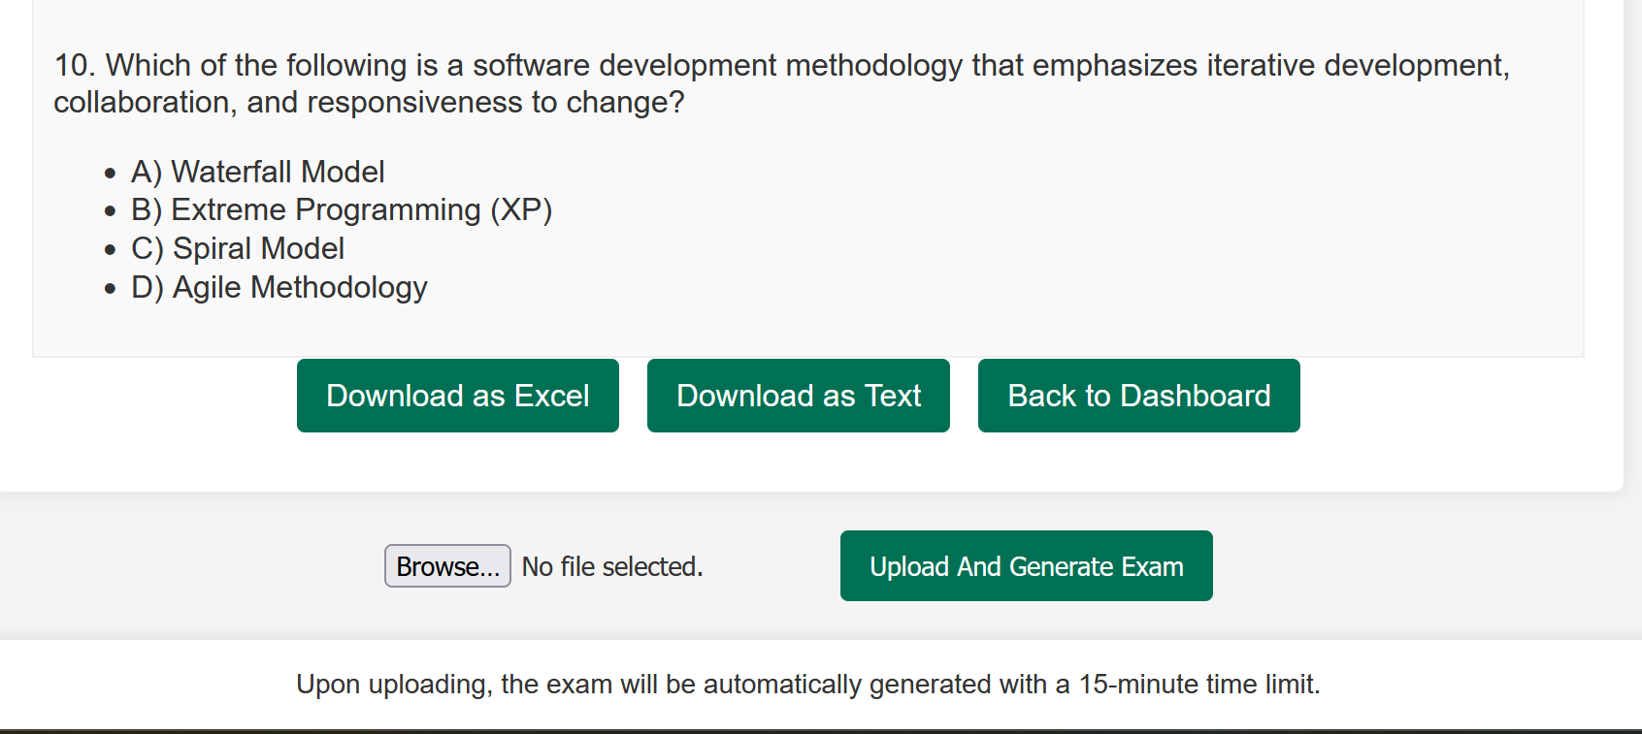

1. Upon downloading the .**txt** file, the instructor **MUST**:
   1. change the answer from “*null*” to the actual correct answer in the form of a letter (A/B/C/D)
   2. Ensure that there are only 4 answer options
   3. Ensure that the file is in the format of:
      1. Question
         1. Answer Option A
         2. Answer Option B
         3. Answer Option C
         4. Answer Option D
         5. Ans: AnswerLetter (A/B/C/D)
   4. Upon changing the answer, the instructor can upload it, and **the exam will be automatically generated** with a 15 minute timer. The answers will be saved in the database.

## **Exam Generation**

1. To begin creating an exam you will need to be logged in as an instructor, then navigate to the ***Exam Generation*** tab on the navigation bar and then select ***Regular Exam Creation*** from the dropdown.

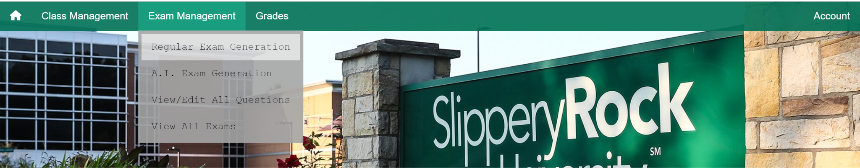

1. You will then be presented with the ***Exam Creation Form***, here you will be prompted to enter the **Course Name**, ***Exam Name, Start Date, End Date and Duration*** of the exam.

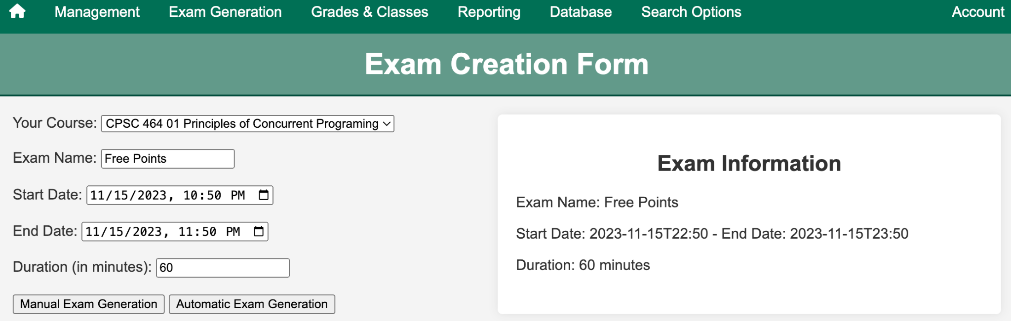

1. You then have two options, ***Manual Exam Generation*** and ***Automatic Exam Generation***

## **Manual Exam Generation**

Upon clicking on Manual Exam Generation you’ll be met with chapter selection. Select your chapter and click “Select”. Once you pick questions, they’ll appear under the Exam Overview

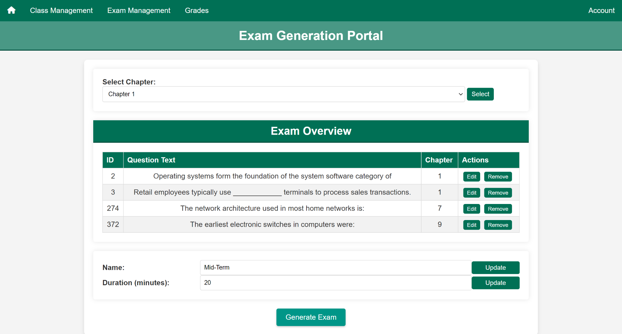

After selecting your chapter, you’ll be met with a question selection/edit screen.

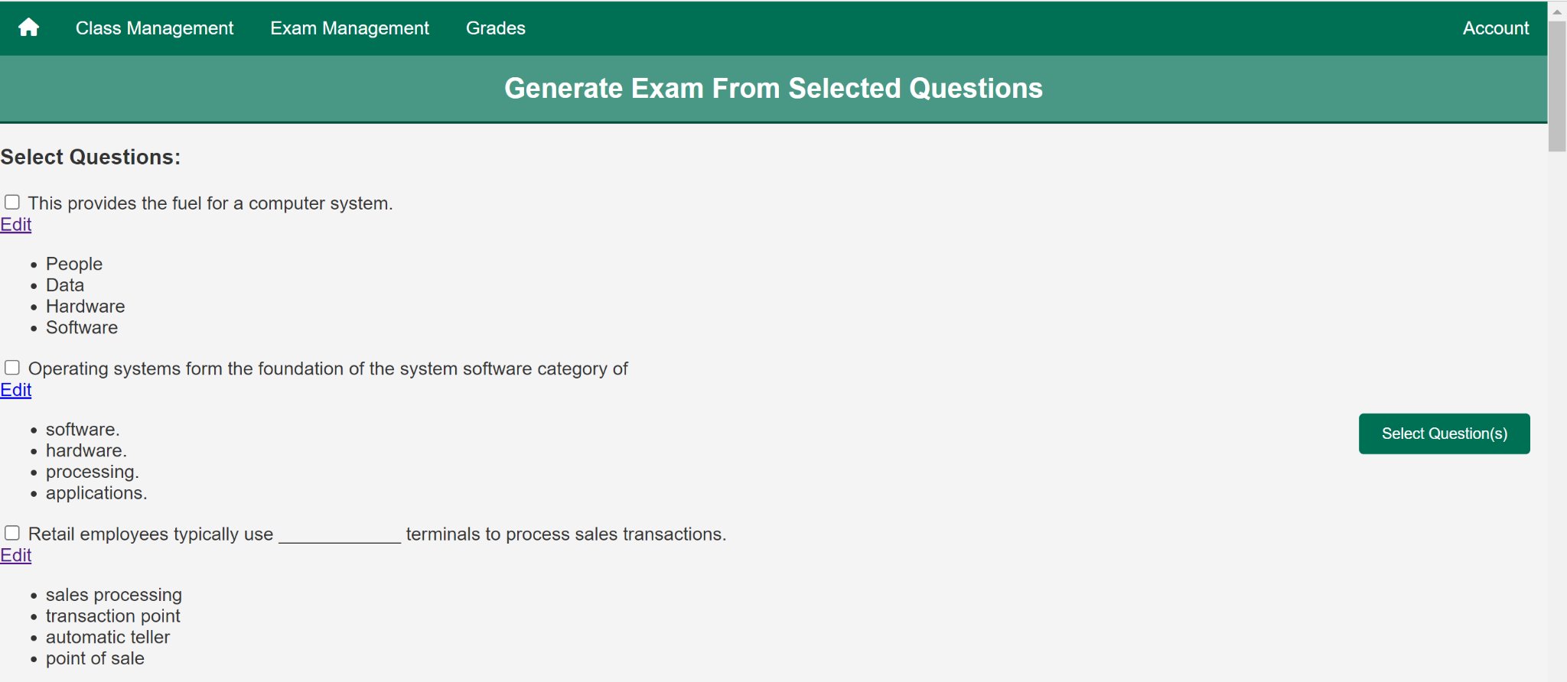

The instructor will have an option to either generate the exam, or add questions from a different chapter by clicking on ‘Add Another Chapter’.

Upon clicking “Generate”, you’ll be met with a confirmation screen as follows:  
  
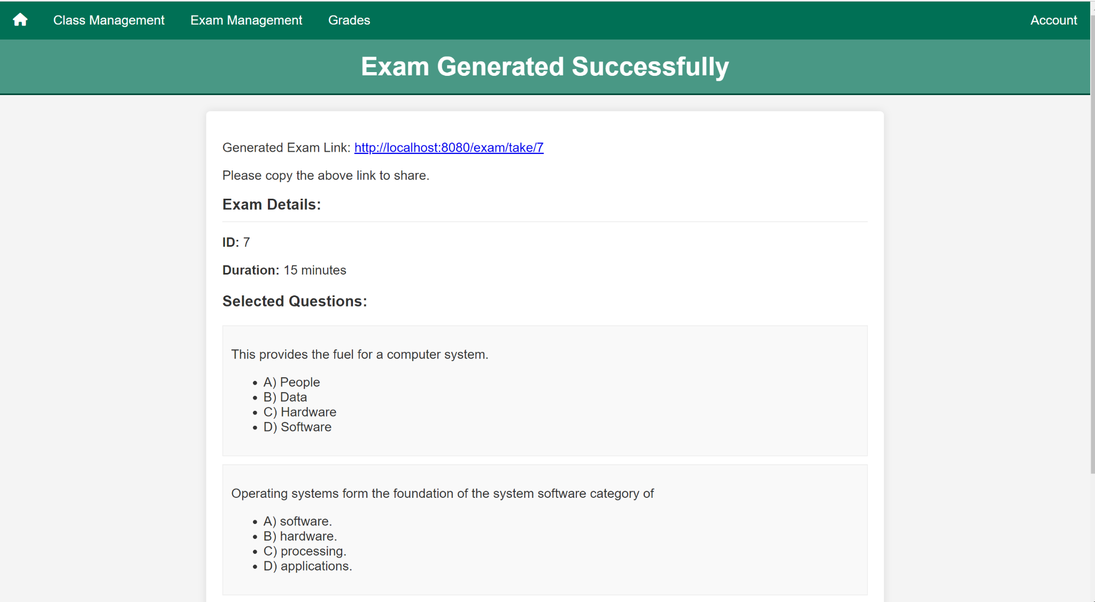

## **Automatic Exam Generation**

1. After you have entered the exam information from the landing page you will need to select the ***Automatic Exam Generation*** button. You will be redirected to the following page.

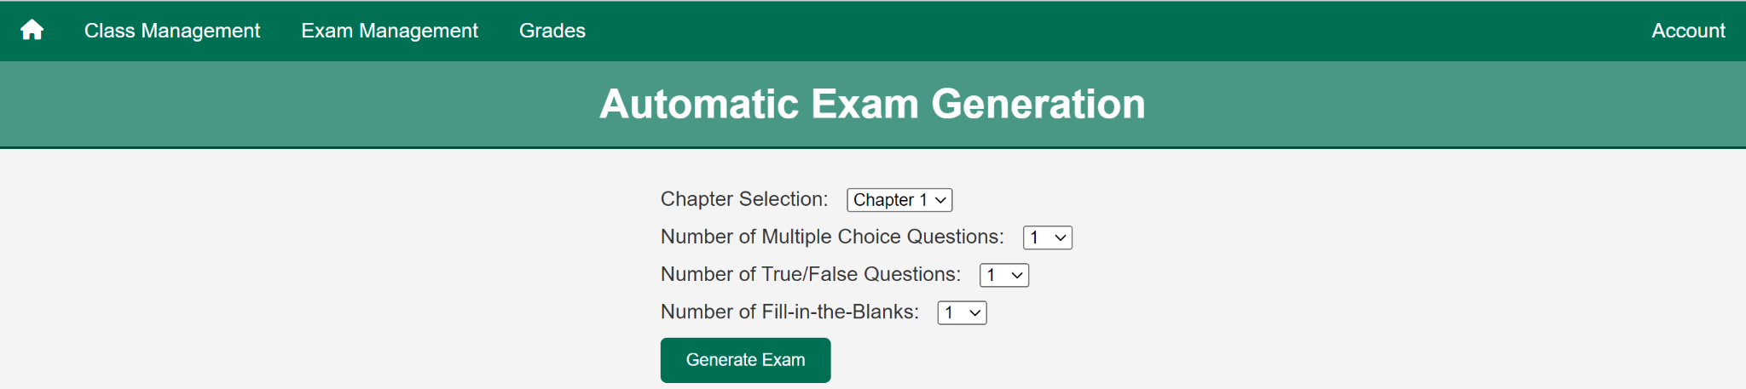

1. From this page you are able to Select the chapter that you would like your questions to be generated from, the number of multiple choice, True/False, and Fill in the blanks.
2. Upon selecting your questions, you will be met with a confirmation page, and a link to your exam.

## **Taking an Exam**

If you would like to take an exam, please ensure that you are logged in as a student or instructor that is associated with an exam that is valid within a course. If you are not, the *Course List* and the *Exam Score and Course* page will only list the courses the logged in student is associated with with no extra data.

Your exam will look something like this:

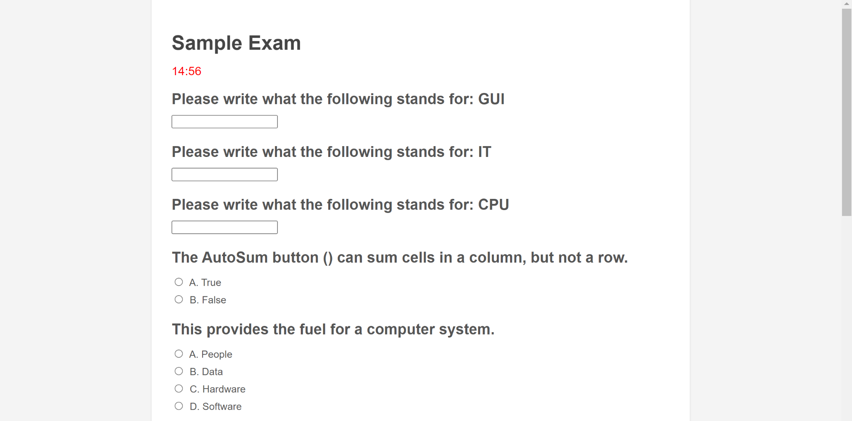

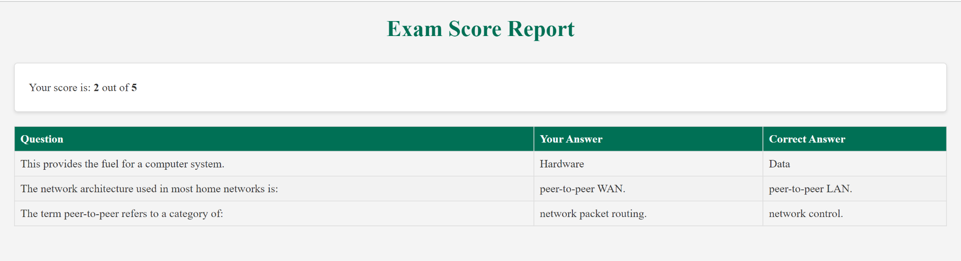

***Your Courses Page***

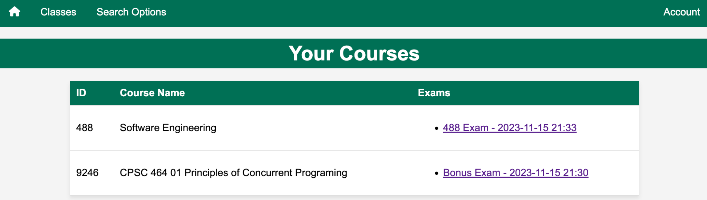

1. This is the page you will come across if the logged in student has a valid exam that is associated with a course, a student is able to click on the exam and it will take them to the exam page:

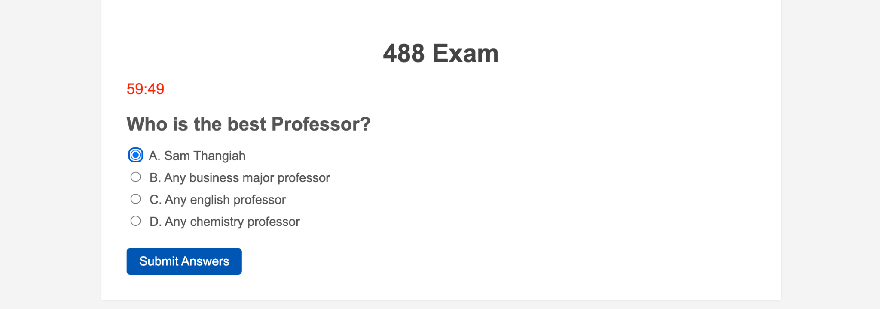

1. The student will then be prompted to take the exam within the time set by the instructor.
2. Once the student is finished they are able to submit the exam.

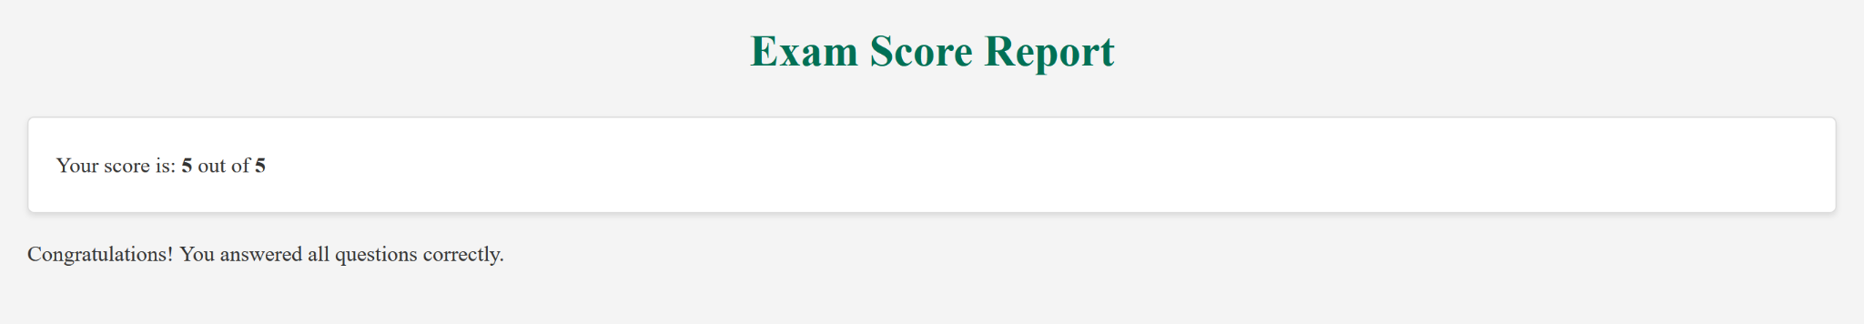

1. The student will then need to go to their Grades tab to view how they have done once the exam has been submitted.

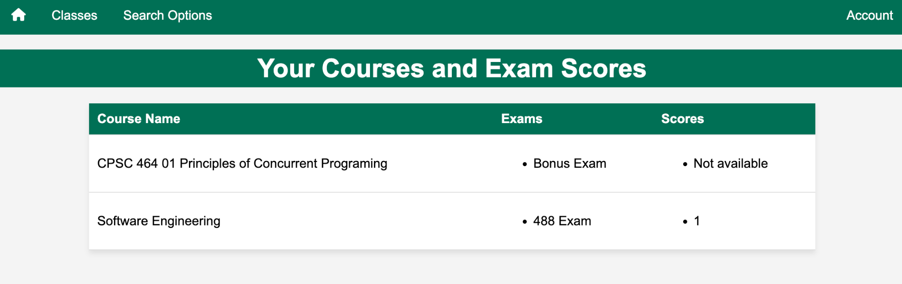

1. If the student has not taken the exam then it will show up as *Not available*, if they have then the correct number of answers will show up under the score.

## **Exam Submissions/Scores**

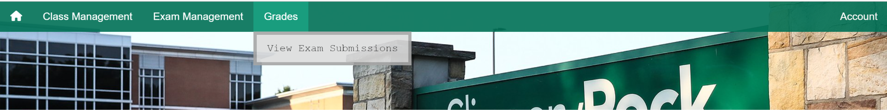

Under the dropdown ‘Grades & Classes’, select ‘Exam Submissions’.

Then, you will be met with the following page where the instructor can see all exam submissions by students, and their respective scores as follows:

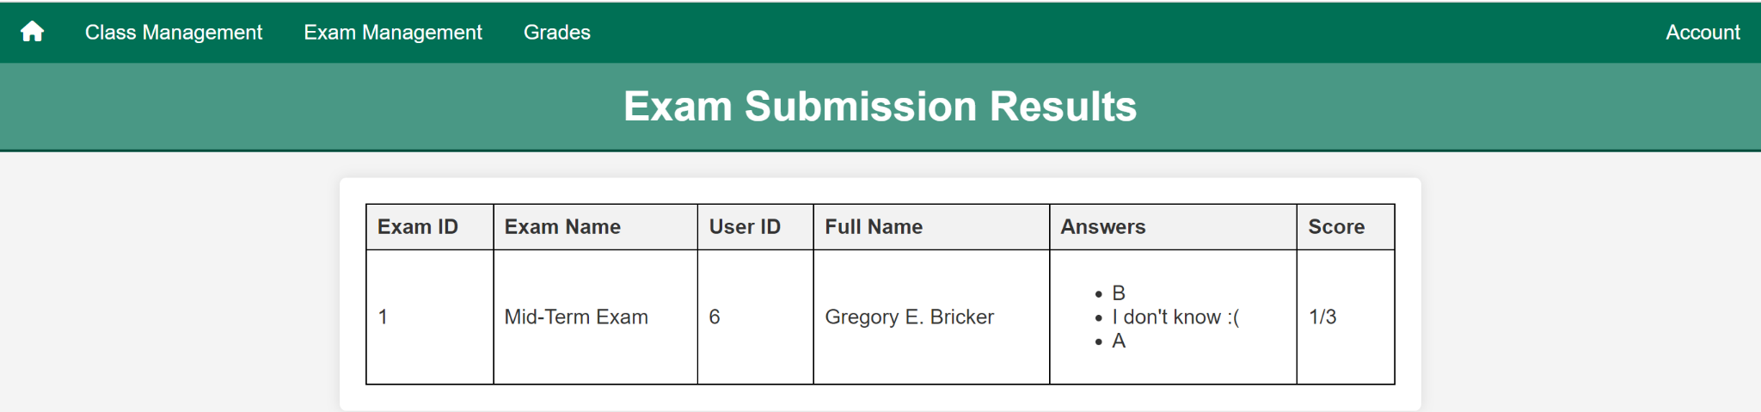

## 

## **Dynamically Managing Questions & Exams**



1. By clicking on the ‘Edit Exam Questions’ as seen above, an instructor can manipulate, edit, add or delete questions and their respective options as they please.

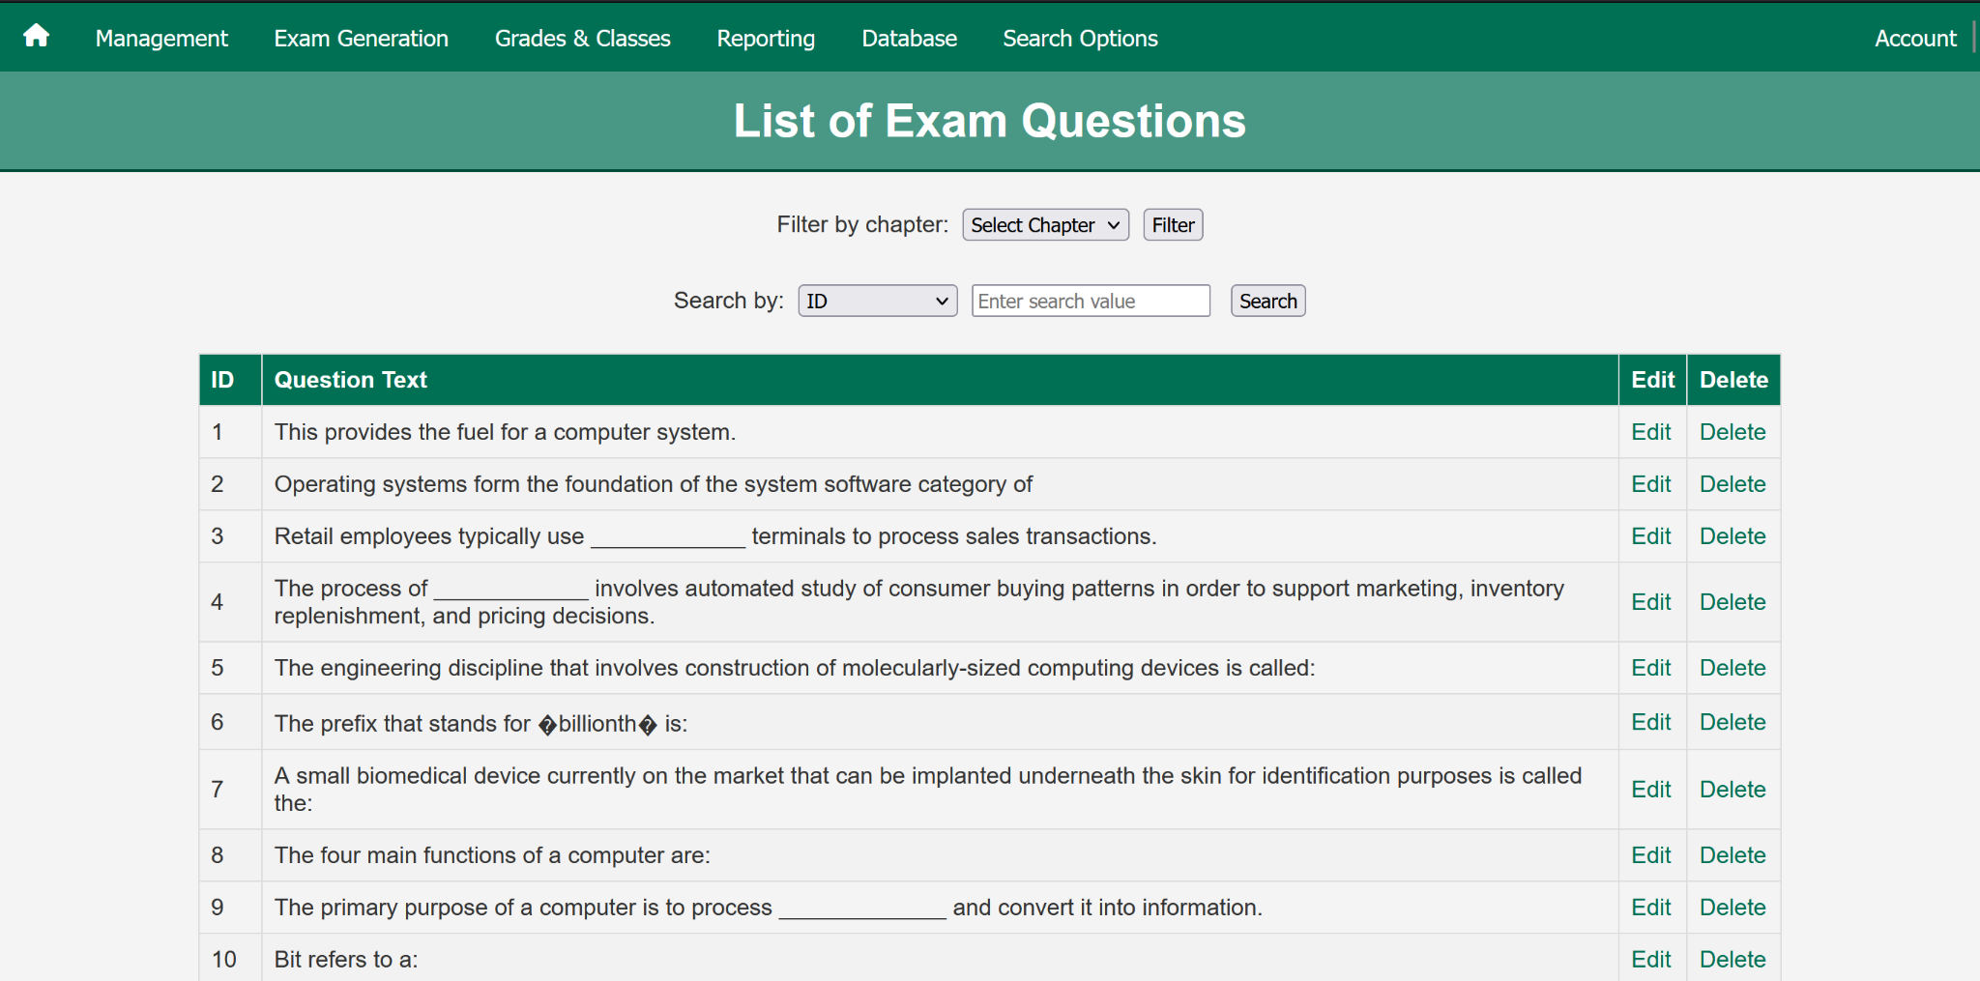

You can filter the question by chapter, search by ID, or question text. You can also manipulate and edit each question.

1. As an instructor, you can also view all exams you have created here:  
    

This is where you’ll see a list of all your exams:  
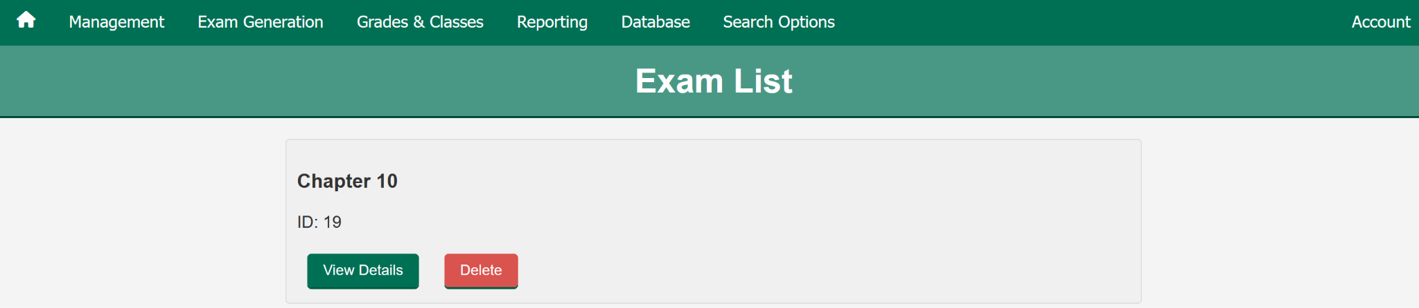

Upon clicking ‘View Details’, you can click ‘Edit Exam’ at the bottom of the page:

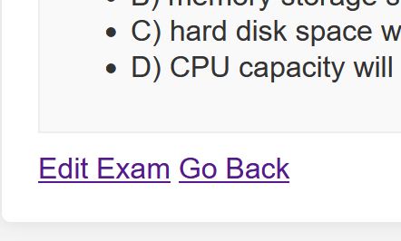

Upon clicking ‘Edit Exam’ you will be met with a page that allows for question addition and/or removal, as such:

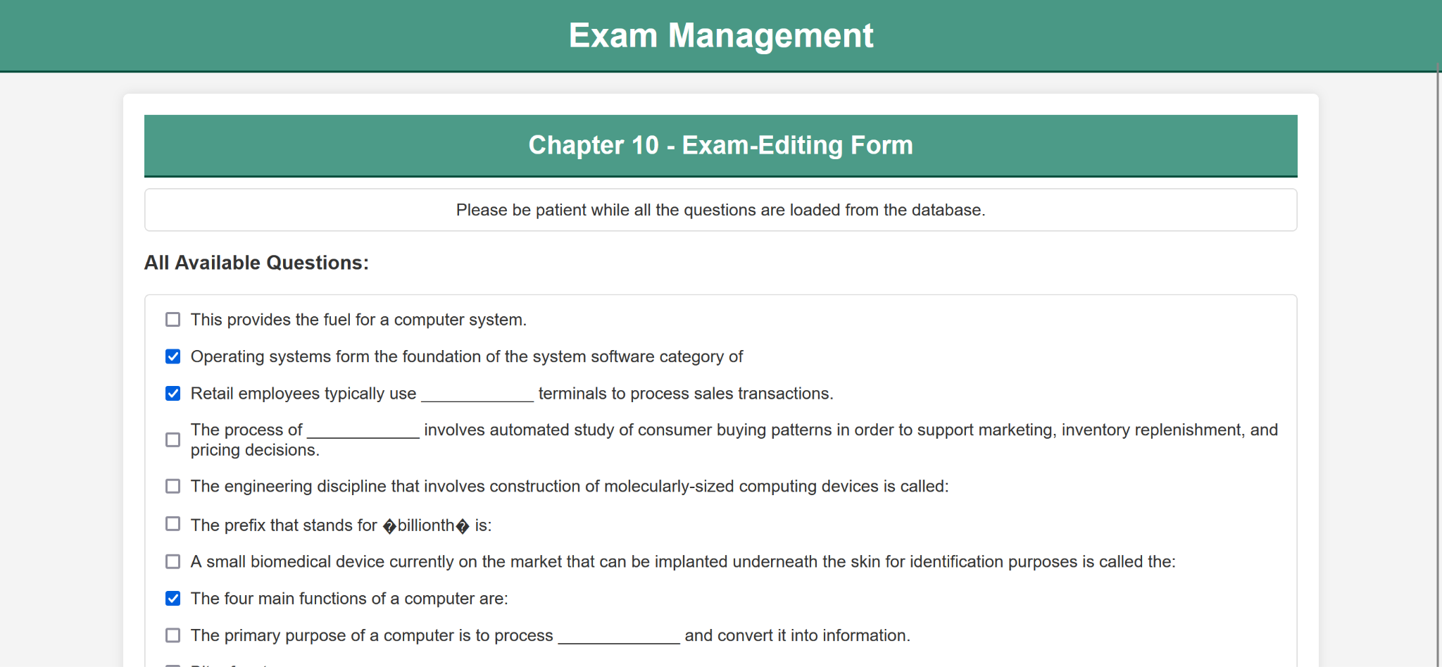

**Please Note:**

Exams can only be deleted, if no submissions on it have been made.

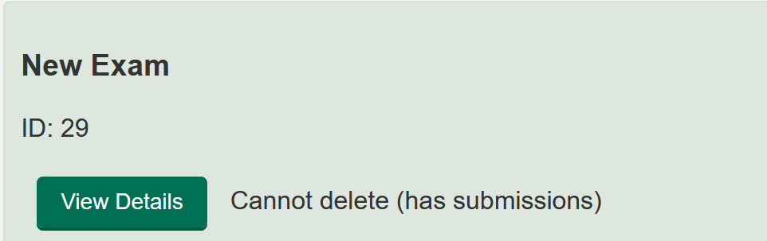

**Logging in as a Schedule Manager**

The default login and password to view the schedule manager homepage are as follows:

**Username: schedulemanager**

**Password: software**

1. You will be prompted with this page

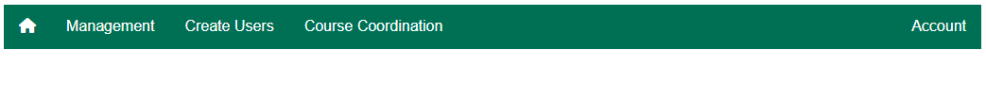

1. You have a navigation bar that has multiple options, the current options that are available are Management, Create Users, Course Coordination. The role of the schedule manager is to handle the associations between the students/instructors and their classes.
   1. Management
      1. View All Instructors - This option will display a page of all the instructors that are created in the database. Under this view you are able to make changes to the Instructors account or delete the account.
      2. View All Students - This option will display a page of all the students that are created in the database. Under this view you are able to make changes to the students account or delete the account.
      3. View All Courses - This option will display a page of all the courses that are currently in the database. Under this view you are able to make changes to the course or delete the course.
      4. Load a Class - this option will display a page that gives you the option to upload a roster of a class, we go into more detail in the section titled **Loading a Class Roster.**

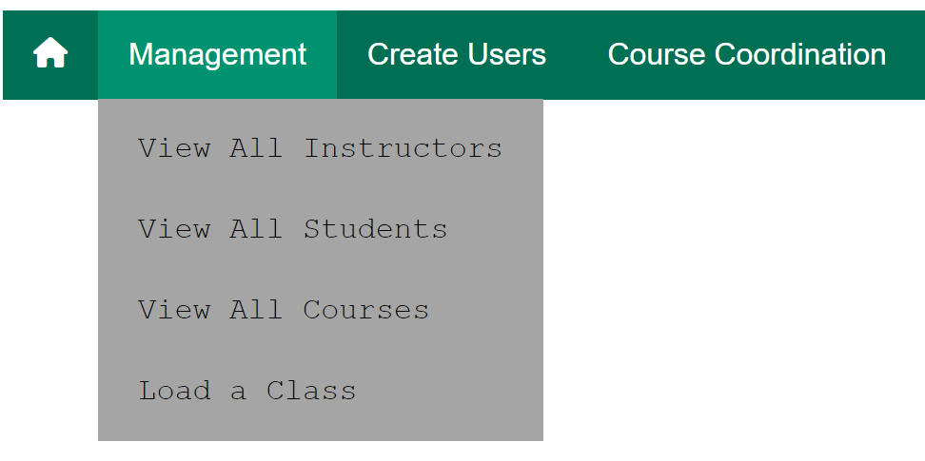

* 1. Create Users-
     1. Add Student - This option allows you to create a singular student account so the student may login to the system.
     2. Add Instructor - This option allows you to create a singular Instructor account so the student may login to the system.

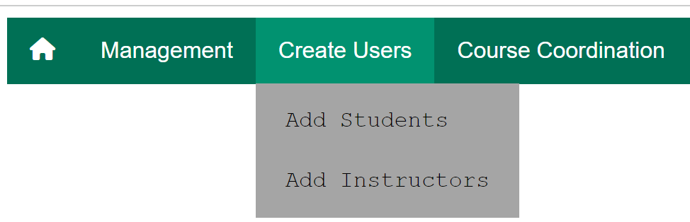

* 1. Course Coordination -
     1. Assign Students - This option allows you to assign a pre-existing student to a pre-existing course.
     2. Assign Instructor - This option allows you to assign a pre-existing instructor to a pre-existing course.
     3. Add Courses - This option allows you to create a course, you are able to name it and give it an ID.

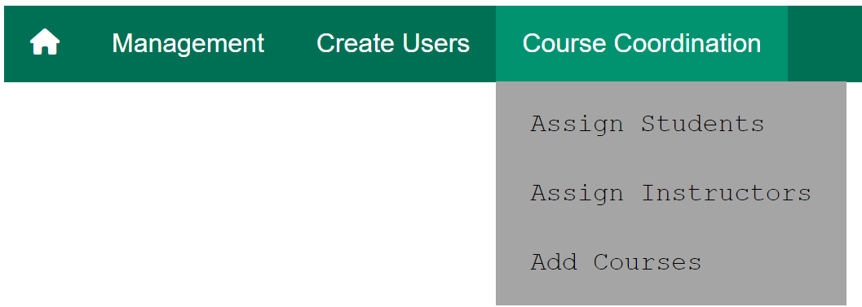

## **Logging in as a Student**

The default login and password to view the Student Homepage are as follows:

**Username: student**

**Password: software**

1. When logging in as a student you will be prompted by this page



1. You have a navigation bar that has multiple options, the current options that are available are **Classes**, **Search Options** and **Account**. The role of the student is simply as it sounds, it is to complete assignments and objectives that the instructor assigns.
   1. Classes
      1. Course - This allows the student to view all the courses they are enrolled in and view the available exams for the course.
      2. Grade - Here the student is able to see the name of the course, the name of the exam they have taken and their score on their submitted exam.
   2. Search options
      1. Search - ***Currently not functional***
   3. Account management
      1. Edit Profile - Account management for student
      2. Logout - Logout function for student

## **Logging in as an Instructor**

The default login and password to view the Instructor Homepage are as follows:

**Username: instructor**

**Password: software**

1. When logged in as an instructor you will be prompted with this homepage



* 1. Class Management has 5 options under it:
     1. Load a Class - This gives the option to the administrator to upload a class and its parameters to the database, and associates the student/teacher with a class.
        1. Choosing file - If you have a file you would like to upload this is where you would upload the file to
        2. Upload - is where you would upload the selected file
     2. Classes - This lets the instructor choose between chapters and different examination forms. This is ***under Development***
     3. Assign Students
     4. Add Students
     5. View Students
  2. Exam Management
     1. Regular Exam Generation - Pick and choose what questions you want to implement based on chapter selection. Edit and manipulate what you want.
     2. A.I. Exam Generation - A full-fledged AI-Exam generator. Simply pick a topic and it will generate an exam for you. See ‘A.I. Exam Generation’ for in-depth user manual information.
     3. View/Edit All Questions - Manage all exam questions
     4. View All Exams - View and manage all exams
  3. Grades
     1. View Exam Submissions - view exam submissions and see student scores.

## **Personal Account Management**

1. Under each account type you are able to edit your personal account information. You need to navigate to the ***Account*** tab in the navigation bar, you will be presented with a drop down and one of options will be ***Edit Account*** when you select this tab you will be presented with a page such as this.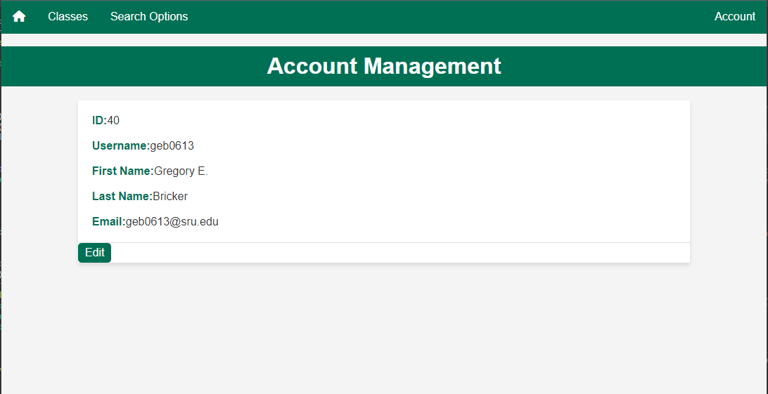
2. If you just need to view your account information you can do that here. If you need to edit your account information you can select the ***Edit*** button, this will present you with a page that looks like this.

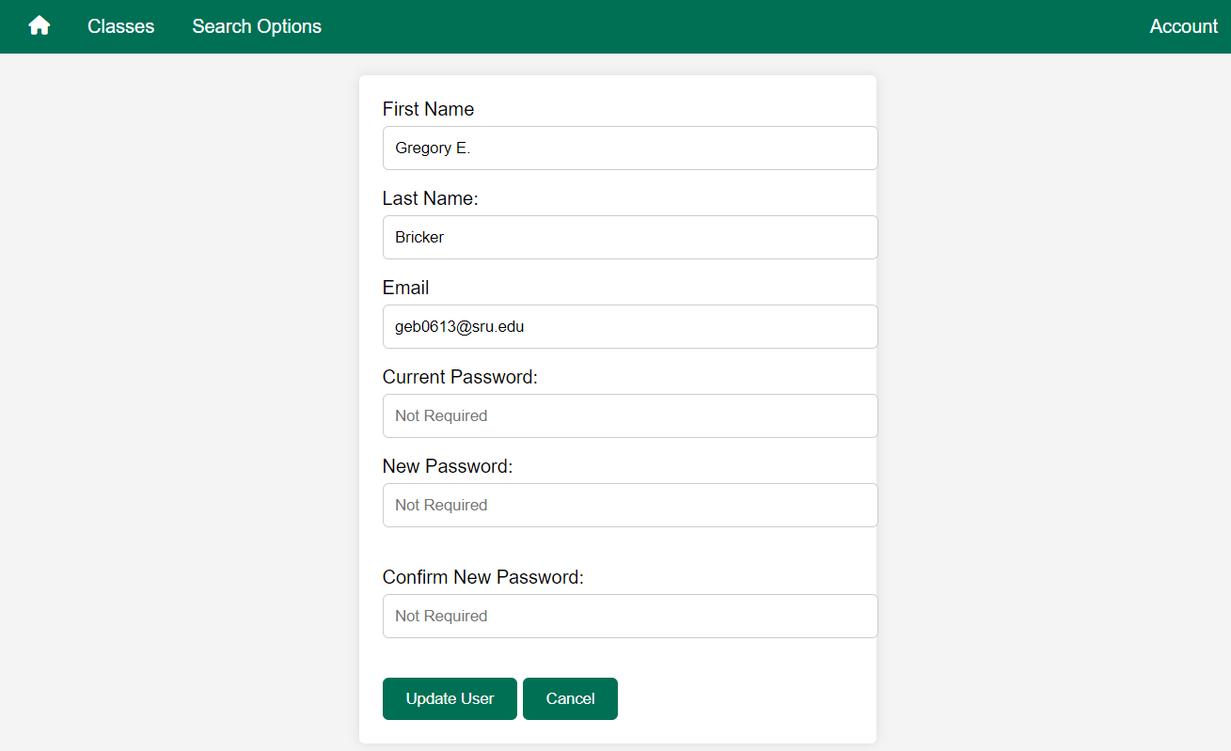

1. On this page you are able to edit each of these fields, one or more, to edit your personal account information. You can save these changes by clicking the ***Update User*** button or click cancel to cancel. 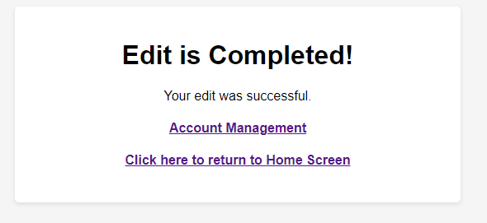
2. If you choose to edit any information and click the ***Update User*** button, you will be presented with a page that looks like this and gives you the option to return to the home screen or to go back to the Account Management page to view the changes that you made.

## **Loading a Class Roster**

* 1. For **testing purposes** there is a file already created and stored in the ***Documents*** folder in our project titled ***class_data_1.xlsx and class_data_2.xlsx*** that has the class roster written and formatted for you.
  2. Before loading the data you can login as a schedule manager, the default schedule manager will work fine for this test and create an instructor, or you can just load the ***class_data.xlsx*** as the schedule manager and it will create the instructors login for you. You can do this under the schedule managers ***Management*** tab and clicking on the ***Load a Class*** if done correctly you will be prompted with this screen.

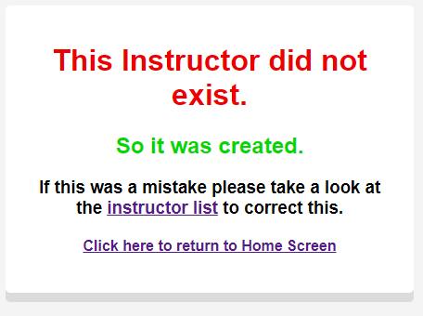

* 1. If you would prefer to create the instructor, for the test data, please create the instructor with the following **squared** information, **non squared** information will not affect the test.

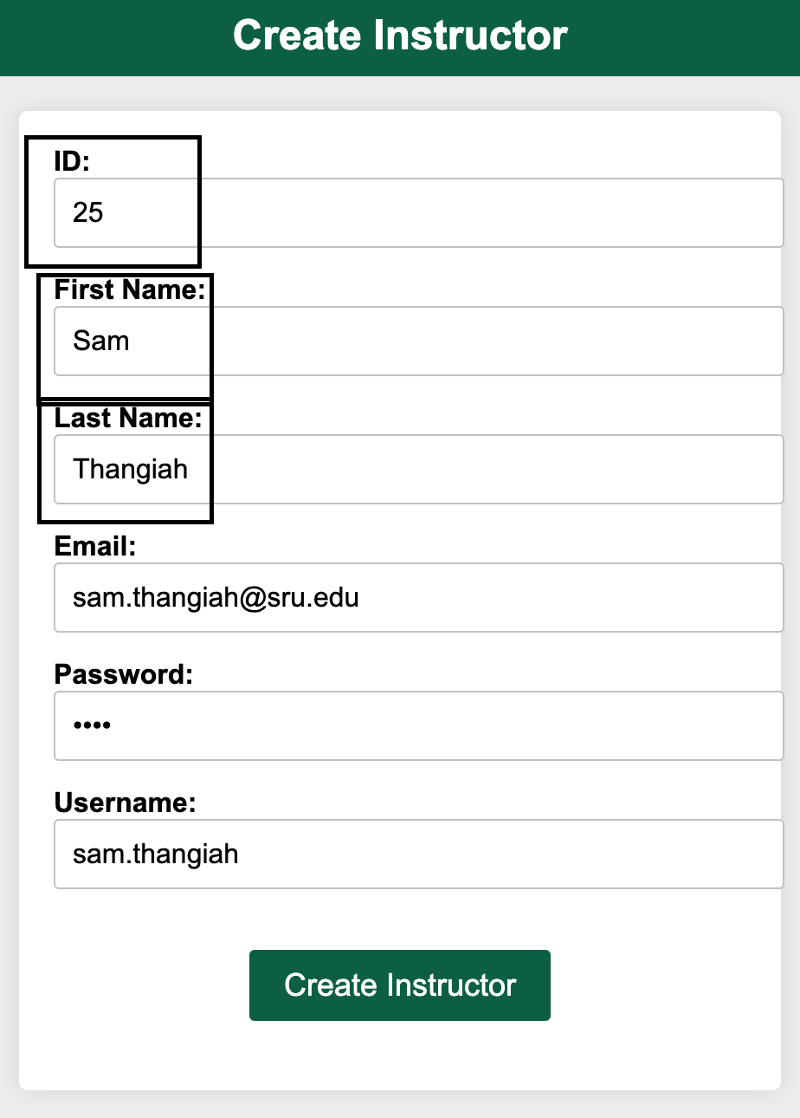

1. First you will need to be logged in as either an instructor (you can use the above mentioned instructor that you created) or schedule manager and use the navigation bar to hover over ***Management*** and select ***Load a Class.***

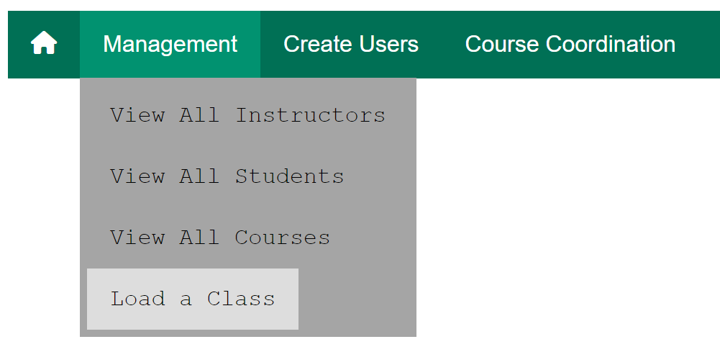

1. You will then need to select ***Choose File*** and use your system file explorer to find your roster loaded with class information.

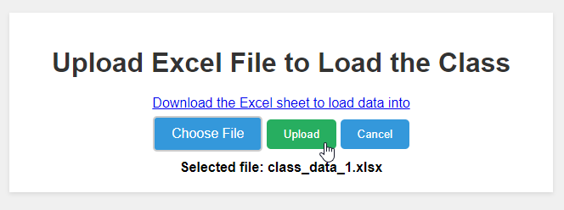

1. Once you select the file you can click upload and you will then be prompted with a success page as long as the roster is formatted correctly.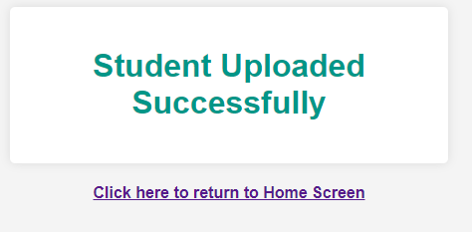
2. You can then navigate to the ***Student List*** page and view the newly added roster of students, you can then login as the student created using their listed ***Username*** and the default password of ***student.***

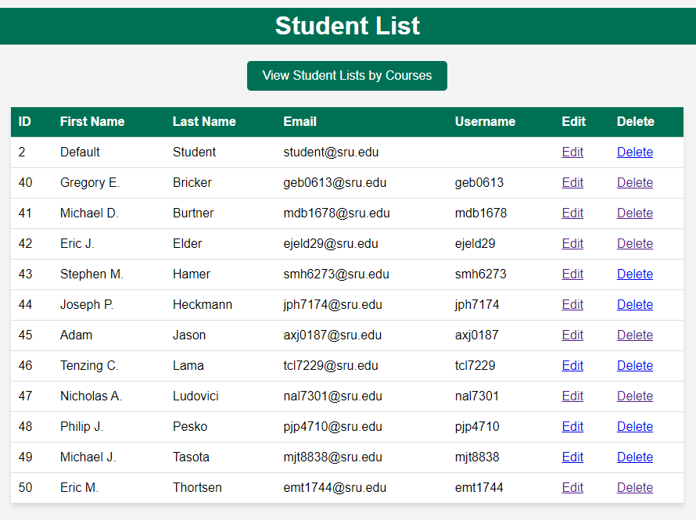

## **Editing a Student**

1. When you need to edit a student, you will need to navigate to the ***Student List*** page while using an administrator, schedule manager, or instructor account type.
2. When on the ***Student List*** page you will find the ***Edit*** option beside the students name.

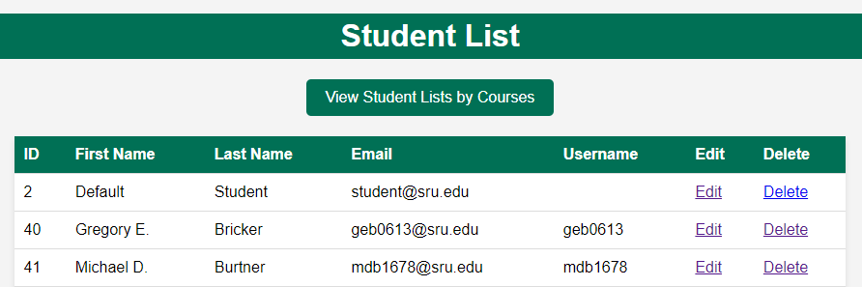

1. When you select the ***Edit*** button, you will be presented with a page where you can edit the students information

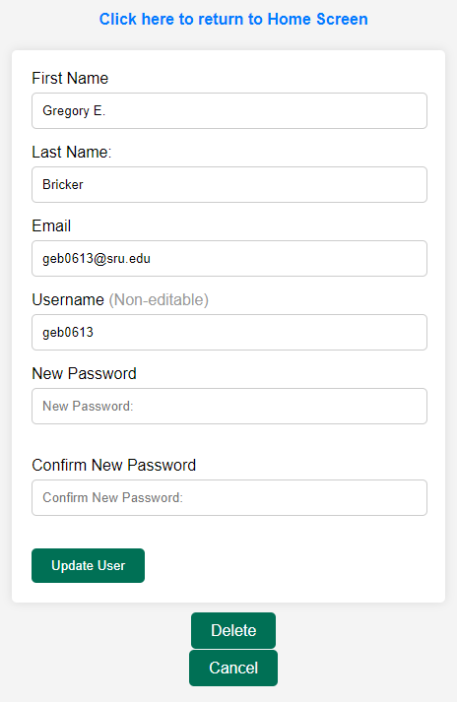

1. The information will be updated in the ***Student List*** page that you can navigate back to from this page.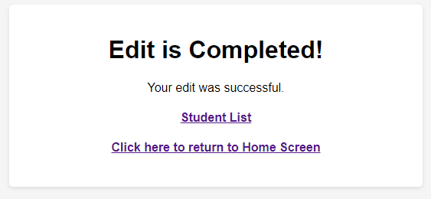

## **Editing an Instructor**

1. When you need to edit an Instructor, you will need to navigate under the ***Management*** tab, when logged in as a schedule manager, and select ***View All Instructors***

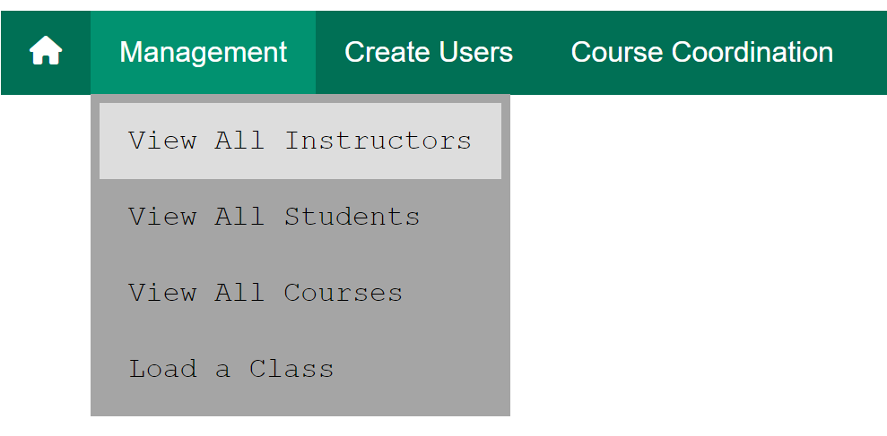

1. You will then be presented with a list of instructors with an ***Edit*** option beside them. You can also search by ***ID, Name, or Username***

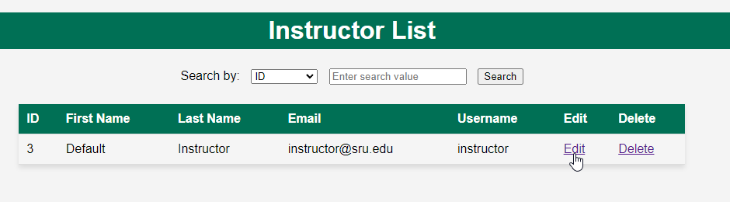

1. When you select the ***Edit*** button, you will be presented with a page where you can edit the instructor's information.

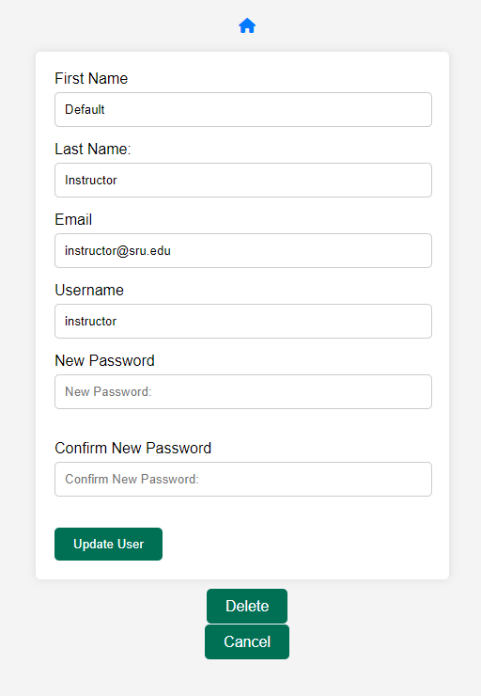

1. The information will be updated in the ***View All Instructors*** page that you can navigate back to from this page.

